Janette Bennett

Week 1 Excel

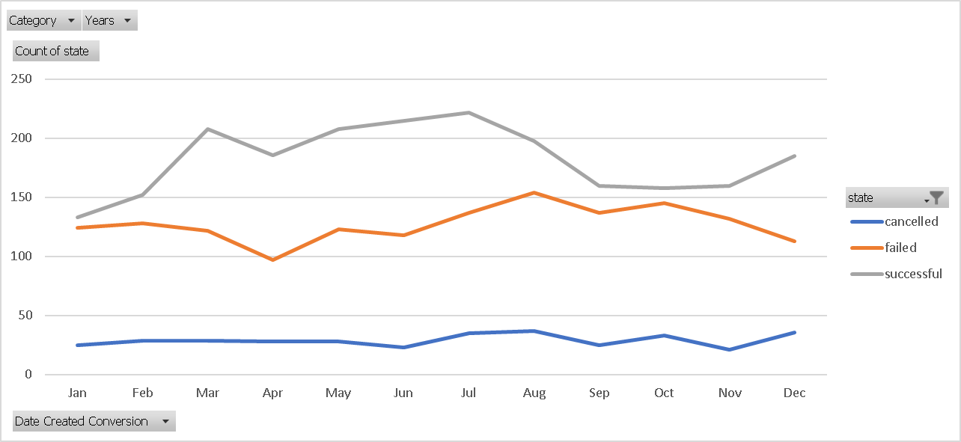

What are three conclusions we can make about Kickstarter campaigns given the provided data?

* There frequently more successful campaigns than failed campaigns.
* Spring and Summer months tend to be more successful than typical winter holiday months, November and December.

What are some of the limitations of this dataset?

* We don’t know anything about the backers and how demographic data impacts these results.

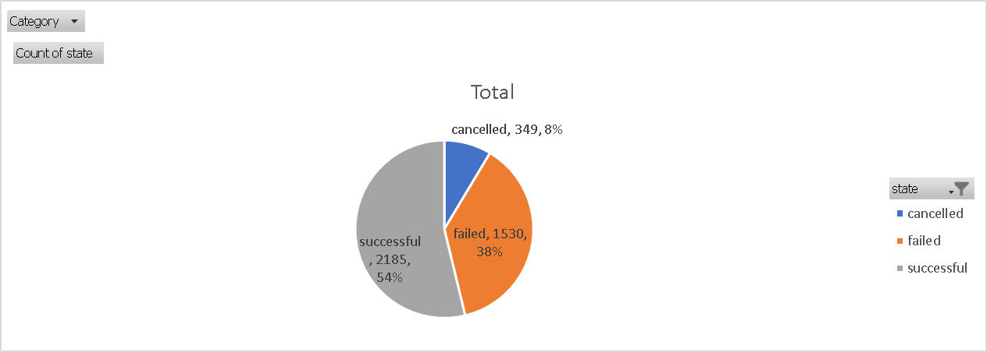What are some other possible tables/graphs that we could create?